**INTRODUCTION**

Drug reporting and verification establishments such as National Agency for Food and Drug Administration and Control (NAFDAC), require an efficient and brilliant technique as well as a flexible system for proper drug management. The main objective is to ensure that production and sale of fake drugs are eliminated. In recent time, there has been an increase in loss of lives due to the use of unverified herbal drugs. This predicament has created the need to build a website that enables the verification of herbal drugs when purchased.

Drugs are referred to as medicine or chemical substances that are administered to patients for curative measures. Drugs are either organized on a cellular basis, i.e. microorganisms, plants, animals or parts of these which have been dried or they are mixtures of substances which have been extracted from microorganisms, plants, animals or parts of these which do no longer have cellular structures, such as essential oils, resins, starch, fats, waxes, isolated mucous substances or animal toxins. Herbal medicine , it is the oldest and still the most widely used system of medicine in the world today and It is medicine made exclusively from plants. Herbal medicine treats diseases and promotes health with plant material. Drug reporting and verification Software easily automates the whole process of drug verification and reporting. Drugs Pharmaceutical Company are register on the system and verification code are generated for each drug production. System users are created by the system administrator where each staff is able to login in with the provided authorization and manage his or her account. The system which will be made available to the general public provides a window in which users could type in a drug code to verify the authenticity of that drug. The administrator has the sole authority over the system. This research work is undertaken to uncover some of the problems with conventional drug reporting and verification systems. Here, agents of NAFDAC and other drug enforcement agency find it quite difficult to access register pharmaceutical companies. Using these conventional methods pose lots of constraint on team member as no team member can access files on the office database while at field work also reports has to be file at the office.

Therefore, it is desirable to find a method of developing a web-based herbal drugs verification and management system in other to verify the authenticity of drugs purchased at the pharmacy. Investigation has revealed that members of public are presently finding it difficult to easily recognize fake and unauthorized herbal drugs bought from the marketer due to non-availability of on-line system designed for such purpose. Hence, a web based Herbal Drugs Verification and Management System of herbal drugs to authenticate the originality of herbal drugs was discussed.

**LITERATURE REVIEW**

Herbal medicine has been an essential component of oriental medicine (OM), which has existed for over two thousand years, guided by principles of Yin Yang, five elements, organs and meridians (Thai, 2004). The herbal medicines include dietary supplements that contain herbs either singly or in mixtures. Also called botanicals, the same are plants or plants products used for their scents, flavor and/or therapeutic properties (Ernst and Pitter, 2002).

Herbal drugs are readily available in the market from health food stores without prescriptions and are widely used in India, China, USA and all over the world (Parmar, 2005). The aforesaid medications have gone in mainstream use and as the sales continue to rise, so do the concerns about their interactions with prescription and over-the-counter drugs (Hu, 2005; Lambrecht, 2000). Over the past decade, there has been an increased global interest in traditional systems of medicine and herbal medicinal products. In part, this surge has been due to the rare or nonexistent access to modern medicine in developing countries as well as the acceptance of herbal medicines by large populations of people in affluent nations (Barnes, 2004; Tindle, 2005; Eisenberg, 1998).

In developed countries, complementary and alternative medicine (CAM), are often used concomitantly with conventional medicine (Khan, 2006). A relevant safety concern associated with the use of herbal medicines is the risk of interactions with prescription medications (Izzo, 2005; Izzo, 2004; Brazier and Levine, 2003; Izzo and Ernst, 2001; Fugh-Berman, 2001; Markowitz and DeVane, 2001; Williamson, 2003).

This issue is especially important with respect to drugs with narrow therapeutic index, such as warfarin or digoxin or drugs used for chronic therapy such as antidepressants and in sensitive patient populations such as older adults, the chronically ill, and those with compromised immune systems (Izzo, 2004; Kaufman, 2002).

Recent examinations have indicated that as many as 16% of prescription drug users consume herbal supplements (Kaufman, 2002). Moreover, fewer than 40% of patients disclose their herbal supplement usage to health care providers and many physicians are unaware of the potential for herb–drug interactions (Klepser, 2000). This lack of information, combined with the fact that herbal medicines are usually mixtures of more than 100 active ingredients, obviously increases the likelihood of interactions. Herbal drug interactions can results in unexpected concentration of therapeutic drug and lead to the undesired effects. Thus, contrary to the popular belief that “natural are safe” (Kaufman, 2002); herbal medicines can cause significant toxic effects, drug interactions and even morbidity or mortality (Parmar, 2005).

**Nature of Herbal Drug**

Most natural products, unlike conventional drugs, are a complex mixture of chemical constituents and often a complete characterization of the bioactive compounds from an herbal is unknown (Chavez, 2006; Barnes, 2004). Additionally, the chemical makeup of natural products varies depending on the part of the plant used (bark, stems, leaves, roots, rhizomes), climate, growing conditions, harvesting, and storage conditions. Combination products composed of multiple natural products complicates matters further. Not only does the complex nature of a natural product complicate the determination of herb-drug interactions, but also the manufacturing process; for example, drying process and extraction methods contributes to the overall complexity.

As previously mentioned, because herbal products are not regulated by the food and drug administration (FDA), there are no standards for herbal products. Indeed, herbal products have been found to be misidentified and/or substituted or adulterated with other natural products or unwanted substances (Fugh-Berman, 2000; Cupp, 1999; But, 1994). Moreover, herbal products are classified and marketed as dietary supplements (Anonymous, 1994). However, the same are regulated differently in other countries. The US FDA mandates that only medicine have to be proven to be safe before being released into market. Herbal products do not fall under the category of drugs as long as they are not marketed for the preventions of any diseases. In United Kingdom, any product that is not granted a license as a medical product by Medicine Control Agency (MCA) is treated as food, and no health claim or medical advice can be given on the label. Labeling of herbal products may not actually reflect the contents and adverse events or interactions attributed to specific herb may be related to mis identification of plant, pharmaceutical drugs or heavy metals (Fugh-Berman, 2000).

**RESEARCH METHODOLOGY**

**Research Approach**

The project was carried out using the following methods:

1. The design of an online Herbal Drug Verification System which is made of modules and a database for searching regarding herbal drugs.
2. To implementation of the designed system in (i) above using database system (MySQL), Html (hypertext markup language), CSS3 (cascading style sheet), J-Query and PHP (hypertext preprocessor)
3. To evaluate the performance of the developed system based on the following criteria
4. Accessibility
5. Speed

**Description of the Developed System**

The developed system was designed to consist of five modules described as follows:

**Home Page**: This page contains all the available commands and serves as a link to all other modules in the program. To access any of the menu command, click at the modules to view all the sub modules. This page enables the administrator to enter their username/ password. If the password entered is valid, the system will then open the program menu. But if the password is not valid the user will be denied access to the program. Its structure as shown in figure 1

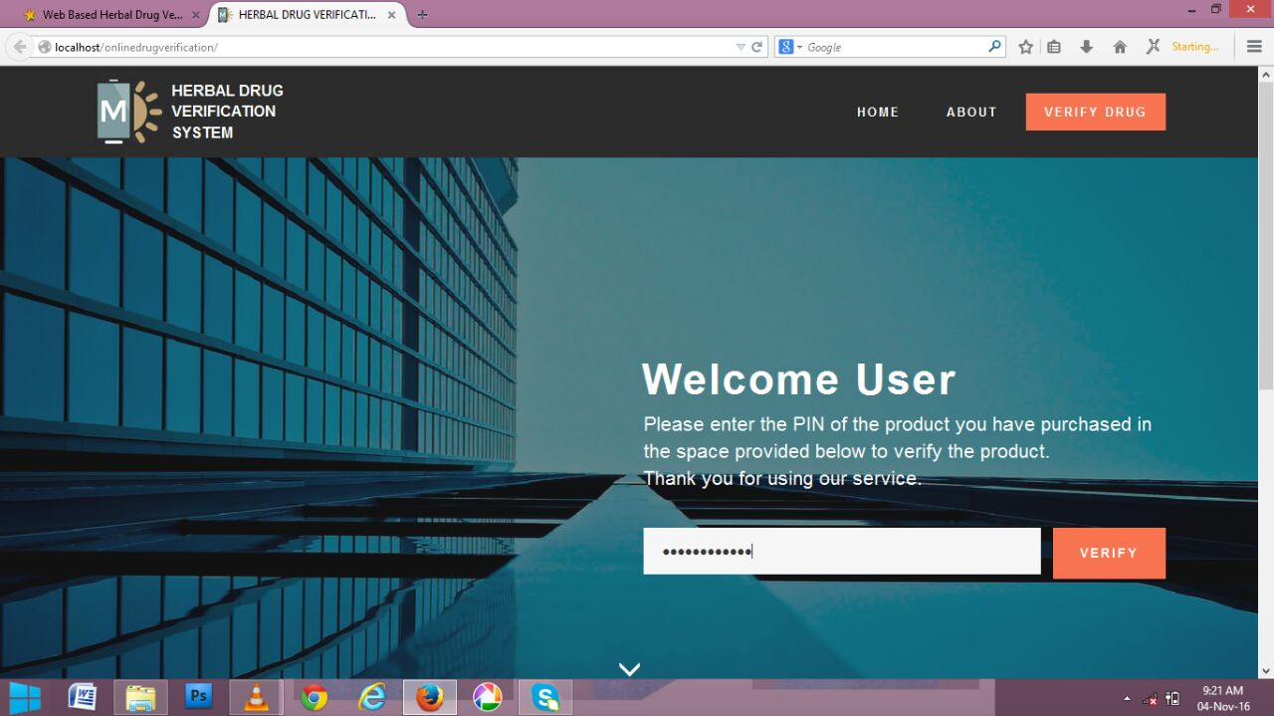

**Fig 1** Home page of the developed system

**Drug edit page:** This is the module that allows user to edit and delete drugs. Its structure as shown in figure 2

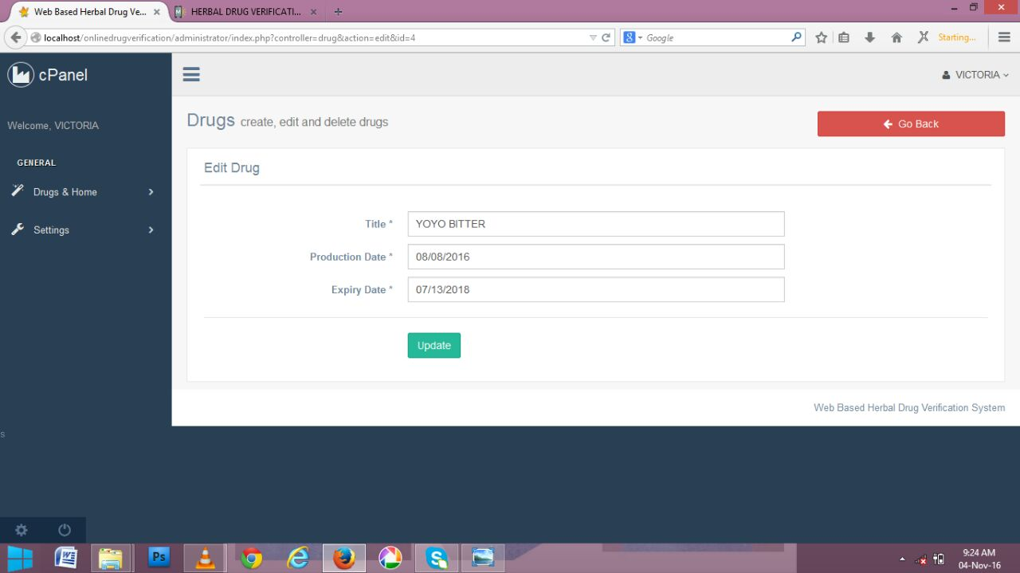

**Fig 2:** Drug edit page of the developed system

**Drug registration Page:** this module enables user to add new herbal drug by supplying herbal drug title, production date, expire date and pin in the space provided. Its structure as shown in figure 3

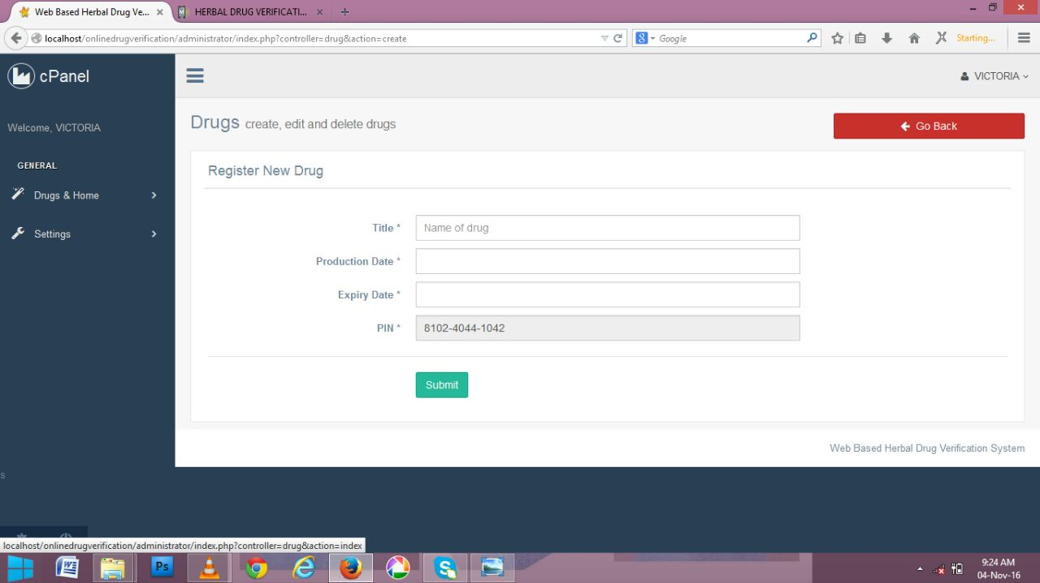

**Fig 3:** Drug registration page of the developed system

**List of registered herbal drug Page:** This page allows user to view all the registered herbal drug and allow them to edit herbal drug record by clicking on the edit button provided at the right hand side of the grid view. Its structure as shown in figure 4

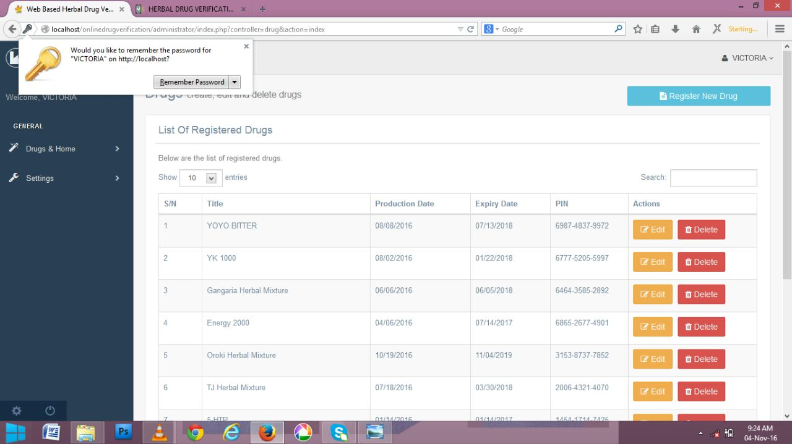

**Fig 4:** List of registered herbal drug Page of the developed system

**Product information Page:** This page displays the status of registered herbal drug. Its structure as shown in figure 5

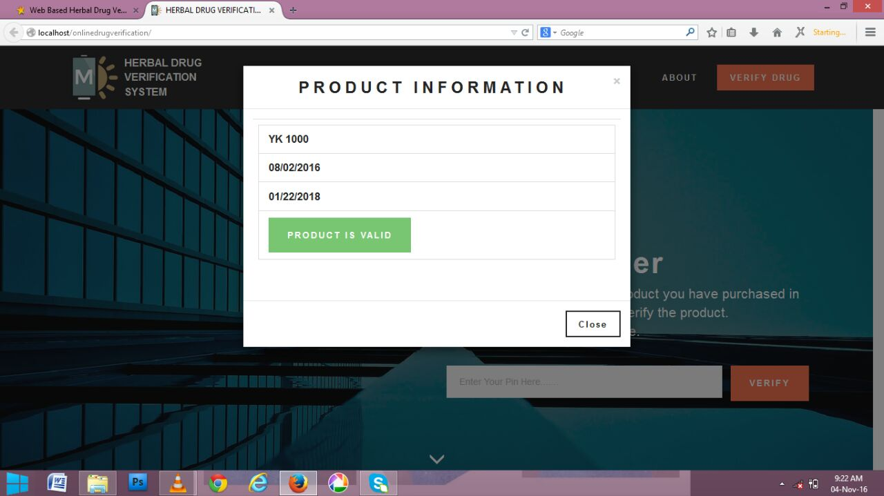

**Fig 5:** Product information page of the developed system

**System Implementation**

The Object Oriented (O-O) paradigm being the natural way of implementing UML designs, the implementation of the tool was done using the O-O style. The programming languages of choice were PHP and MYSQL. The detailed documentation obtained at the detailed design stage was translated into classes of the target programming language. An attempt at separation of the graphical user interface (GUI) and the functionality was made. This was to enable the development of a loosely coupled system.

**Evaluation of the Developed System**

Evaluation of the developed system was carried out based on the following criteria;

**Accessibility**

After the system had been tested, the result shows that the new developed system is accessible i.e. the new developed system was available at any convenient time of the users and responsiveness, user can access it anytime they need it or fill like using the new developed system.

**Speed**

From the test and the result generated shows that the new developed system performs all the necessary things it supposes to perform and it does not keep the user wait. The test performed shows that the efficiency and effectiveness of the new developed system is very easy to use, user friendliness and fast in operation.

**Evaluation Methodology**

The discussed system was evaluated by administering questionnaire on eighty (80) users. The completed questionnaire were collected and analyzed.

**RESULT AND DISCUSSION**

**Results**

The result of the evaluation of the developed system is as presented in tables 1, 2 and figures 6 and 7 below:

Table 1: Response of the users on the accessibility of the developed system

|  |  |  |
| --- | --- | --- |
| **The developed system is easy to access** | **Frequency** | **Percentage** |
| Strongly Agree | 55 | 68.75% |
| Agree | 15 | 18.75% |
| Disagree | 7 | 8.75% |
| Strongly Disagree | 3 | 3.75% |
| **Total** | **80** | **100%** |

**Figure 6:** A Graphical Representation of the newly developed system accessibility

**Table 2:** Response of the users on the speed of the developed system

|  |  |  |
| --- | --- | --- |
| **The developed system is very fast in operation** | **Frequency** | **Percentage** |
| Strongly Agree | 60 | 75% |
| Agree | 15 | 18.75% |
| Disagree | 5 | 6.25% |
| Strongly Disagree | - | 0% |
| **Total** | **80** | **100%** |

**Figure 7:** A Graphical Representation responses of the developed system speed

**Discussion**

Table 1 and figure 6 shows that 70 out of 80 users agreed and only 10 disagreed that the system is easily accessible. Also Table 2 and Figure 7 shows that 75 out of 80 users agreed that system is very fast in operation. From the result shown in the table it is concluded that majority of the user agreed that the system is easy to accessible and fast in operation.

Hence the developed system is capable of allowing prompt and unrestricted access to verify herbal drugs information.

**CONCLUSION**

In this Seminar report, a web based on herbal drugs was discussed using MySQL, Hypertext markup language, CSS3, J-Query and PHP. The discussed system was also evaluated based accessibility and speed

It is then concluded that the objective of the study were achieved and the system developed is capable of allowing prompt and unrestricted access to verify herbal drug information.

**RECOMMENDATION**

It is recommended that:

1. It is recommended that the Nigerian hospital, chemist and public users are adequately trained on the use of Information Technology in herbal drug verification system.
2. Computer literacy program should be organized for the hospitals and chemist. This can be carried out set by set. At the end of the training, it is recommended that the herbal drug verification system be deployed to every hospitals, chemist, and public user for verifying herbal drug information.

**REFERENCES**

Bahol, R. (2004). Implementing an Integrated Computer Patient Record. Department of Computer and Information Science. British Journal of Hematology: Linkoping University Sweden.

Brian, T. (2006). Database Design and Management. (3rd ed.).Practice Hall Publishers: New York.

Codd, E. (1970). A Relational Model for Language Shared Banks. In Communication for Data Banks.

Date, C. (2003). An Introduction to Database System (5th ed.). Addison Wesley Publisher: London.

Enwere, J. (2002). Records Management in Nigeria Library and Information Service Review. Akin Publishing Limited: Lagos.

George, W. Reynolds, & Ralph, M. (2008). Principles of Management Information System (3rd ed.). Jossey-Bass Publishers: UK.

Greg, P. (2001). Teach yourself Visual Basic 6 in 21 days. Macmillan Computer Publishing: London.

**[**

Hu et al., (2005). *Centralized Automated Herbal Drug Dispensing System*. (Healthcare): USA.

Izzo, O. (2005). Software Engineering Methodology (2nd ed.). Federal University of Technology Owerri pp310: Owerri.

Kenny, S. M. (2008). Database Backup and Recovery Basics. Retrieved from <http://www.download.oracle.com.2012-07-12>.

Khan, E. (2006). Automated Drug Inventory Control System BSc. Project work. Federal University of Technology: Owerri.

Klepser et al., (2003). Approach to the Design of Medical Decision Making System. Macmillan Computer Publishing.